TO
The Insurance Ombudsman
4th Floor, Bhagwan Sahai Palace
Main Road, Naya Bans
Gautam Buddh Nagar Sector 15
Noida – 201301
oio.noida@cioins.co.in

Date: 28 September 2025
Subject: Submission of Annexure VI-A and Consent – Complaint No. NOI-H-056-2526-0961
Dear Sir/Madam,
With reference to your notice dated 27-09-2025 regarding my complaint No. NOI-H-056-2526-0961 against ACKO General Insurance Co. Ltd. (Bangalore), I am hereby submitting the duly completed Annexure VI-A along with my unconditional consent as required under Rule 13(2) of the Insurance Ombudsman Rules, 2017.
Details of the complaint are as follows:
- Complainant’s Name & Address:
Mr. Vikas Gandhi
D-20, 1st Floor, Dayanand Nagar,
Ghaziabad, Uttar Pradesh – 201001
Mobile: 9911198000 | Email: 9amdeal@gmail.com
- Insurance Company Details:
ACKO General Insurance Co. Ltd. (Bangalore)
36/5, Hustlehub One East, Somasandrapalya,
27th Main Road, Sector 2, HSR Layout, Bengaluru – 560 102
- Policy Number: ASHP202400001607
- Complaint Summary:
Wrongful rejection of Health Claim No. 25062100350/1 despite medical necessity. Surgery was emergent and not elective; biopsy confirmed Lichen Sclerosus (Balanitis Xerotica Obliterans). The insurer wrongly applied a general exclusion clause not applicable to this case.
- Monetary Loss: ₹37,358
- Relief Sought:
  - Settlement of claim amount ₹37,358
  - Additional compensation of ₹10,000 for harassment and mental agony
- Representation to Insurer:
Escalations were made up to the Chief Grievance Officer, but the insurer reiterated its rejection (final response on 2 July 2025).
- Legal Proceedings: None pending before Court/Forum.
- Policy Portability: Fresh Policy.

Unconditional Consent:
I hereby give my unconditional and irrevocable consent for the Insurance Ombudsman to act as a mediator between myself and the Insurance Company and to provide recommendations for the resolution of my complaint. I also consent to participate in an Audio and/or Video Hearing if required.
I kindly request you to acknowledge receipt of this submission and initiate the resolution process at the earliest.
Yours faithfully,
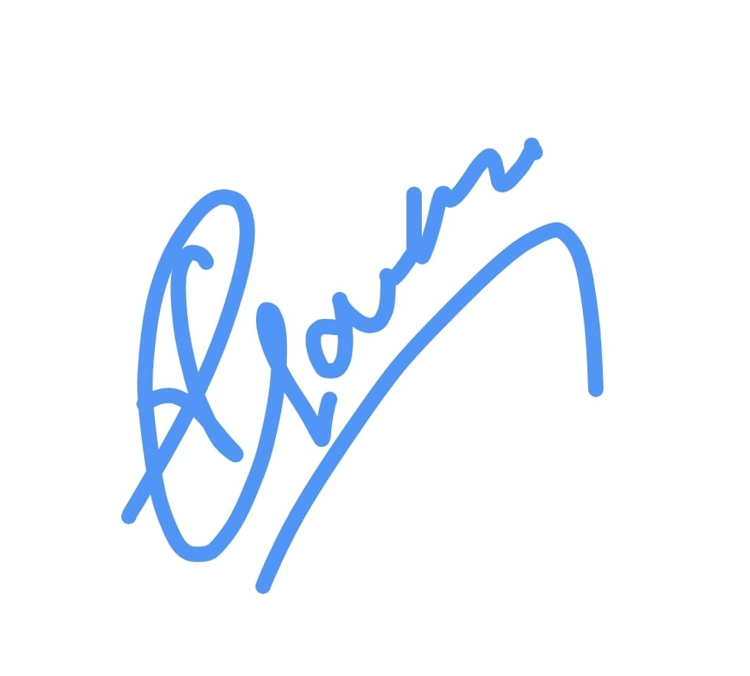
(Signature)
Vikas Gandhi
D-20, 1st Floor, Dayanand Nagar
Ghaziabad, Uttar Pradesh – 201001
Mobile: 9911198000
Email: 9amdeal@gmail.com

